Registration form the closing ceremony
(29 september 2018)
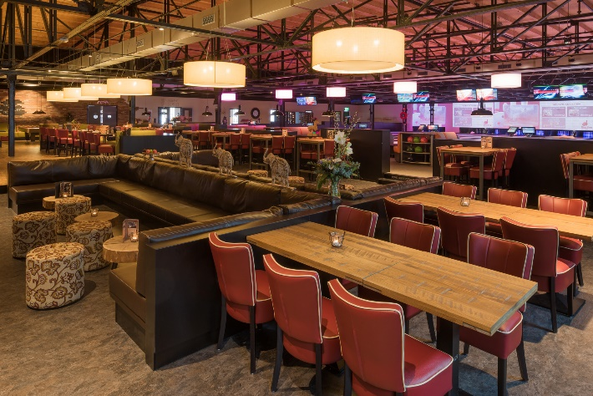
Evening program:
- Buffet: 18.00 tot 20.00 hours
- Party: 20.00 tot 01.00 hours
- Buffet en Party: 18.00 tot 01.00 hours

(Club) name:
E-mail:

You can enter your choice and the number of persons below in the box:
………X | Buffet á € 20,- per person | = | €………
………X | Party á € 5,- per person | = | €………
………X | Buffet en Party á € 22,50 per person | = | €………
Total €

You can register with your details and your choice before 31 August 2018 via the e-mail address:
zbsd10jaar@zbsd.nl

Please transfer the total amount to NL 32 RABO 0146 1700 40. ZBSD in Bergen op Zoom with your name and 10 years of tournament party evening. We request that you pay this amount before 1 September 2018.

