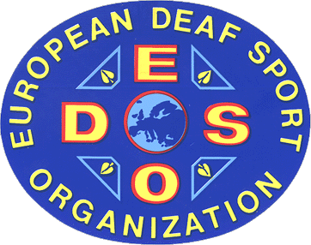

E U R O P E A N D E A F S P O R T O R G A N I S A T I O N

European Deaf Sport Organisation  Vasyl Sandugei – representative  Olga Dula – technical director  E-mail: orienteering@edso.eu  Copy: sandugei@edso.eu | Name registration: 25.06.2016

Registration by name for the participation in the
3rd European Deaf Junior Orienteering Championship
from 25th July until 30th July 2016 in Olomouc/CZE

Nation: ______________________

No | Family name | First name | Birthday | In ICSD audiogram list ID number
MEN ATHLETES
01.
02.
03.
04.
05.
06.
Reserve
WOMEN ATHLETES
01.
02.
03.
04.
05.
06.
Reserve
OFFICIALS Functions
01.
02.
03.
04.
05.
06.

Confirmation

Date, Place |  | President |  | Secretary General

